 |  | 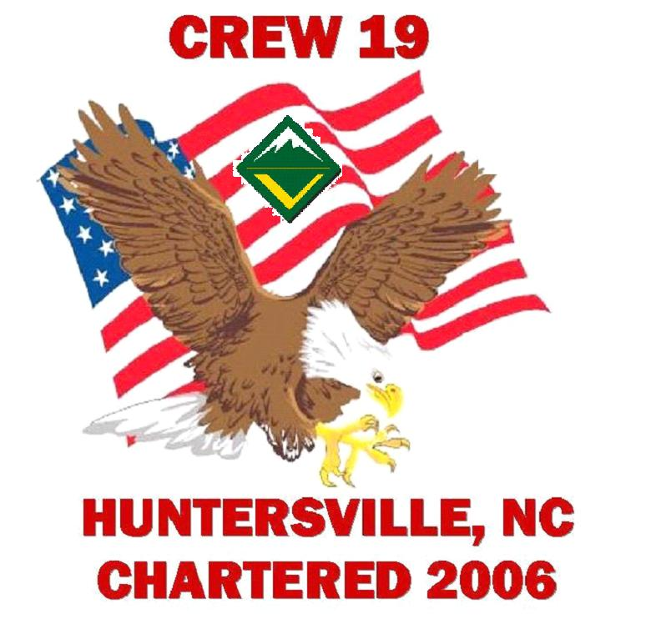

Troop 19/Crew 19 Activity Information Flyer

Activity:

Date:

Adult(s) in charge:

Contact Email Address:

Trip location/s:

Drop off location and time:

Pick up location and time: Will call when we are 1 hour away from the church

Activity Cost:

Gas:

Please also be sure to include any special information:

- Patrol camping
- Bag lunch
- It cold… wear warm clothes

Sign me up!!!!

Name:

Patrol:

Amount paid: $

